**Assignment 3**

**Name:** Muhammad Fahad

**ID:** FA19-BSSE-0014

# **Course**: Operating Systems

**Section:** AM

**Teacher:** OSAMA AHMED KHAN

**Assignment 3**

**Q 1. Consider Figure 1 for this question. Assume turn = 0 initially. If after leaving Critical Region, for Process 0, turn is set to 0 instead of 1, and for Process 1, turn is set to 1, instead of 0, then diagnose the following:**

1. Any general issue(s) with the modified code. (4 points)
2. Violation of any of the four Inter-Process Communication conditions in the modified code. (4 points)

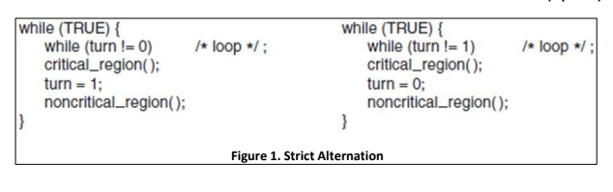

1. **Any general issue(s) with the modified code.**

**Process 1** will forever do busy wait because firstly **Process 0** will go to its **Critical Region** and do its work on leaving it also set the turn to 0, so **Process 1** will never be able to go **Critical Region.**

1. **Violation of any of the four Inter-Process Communication conditions in the modified code.**

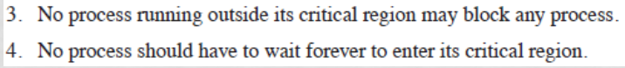

The modified code **Violation the third, & four Inter-Process Communication** conditionsby doing **busy waiting** as well as **forever blocking** a process to go its **Critical region**